Carlos Sanchez

Website to Download Demographic and County Datasets:

URL: <https://data.chhs.ca.gov/dataset/vaccine-progress-dashboard>

**Visualization of Data**

**Pie Chart**

Step 1: Retrieve the csv files titled, Statewide Covid-19 vaccines Administered by county and Vaccines administered By Demographics





Step 2 :Log in to your elastic cloud and then into Kibana

Step3:Once you arrive on Kibana click on machine learning which is under kibana

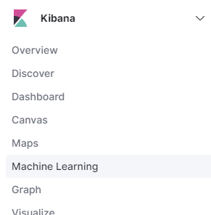

Step 4:Click on data visualizer and then on import data

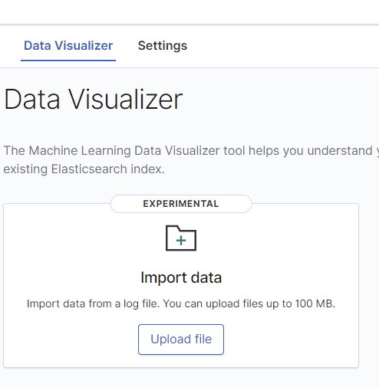

Step 5: Drag in the csv file we downloaded from step 1

Step 6: It will analyze the data and then you click import at the bottom left of the screen

Step 7: Once it is imported make sure the “creat index pattern” box is checked and put an index name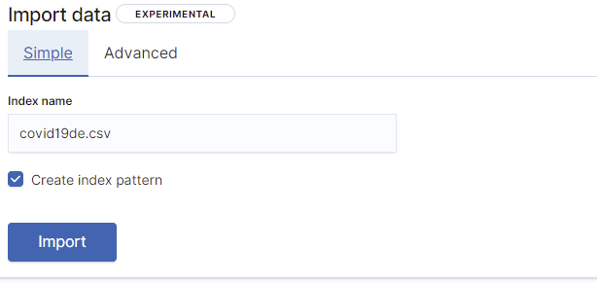

Step 8: Click on import and this should pop up

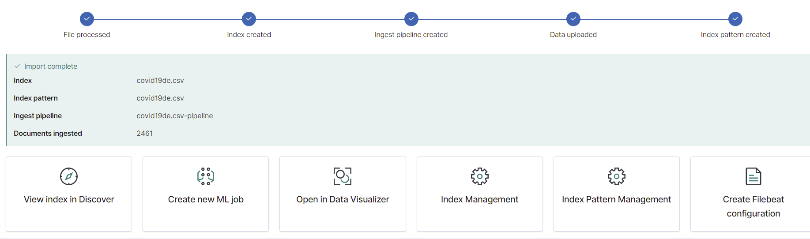

Step9: From here go to the visualization tool to visualize the data we have imported

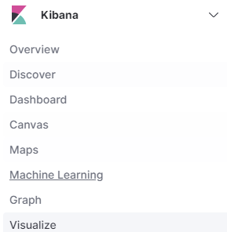

Step

Step10:Click on create visualization and choose pie chart which will then ask you to choose an index pattern. Choose the one you have created from previous steps

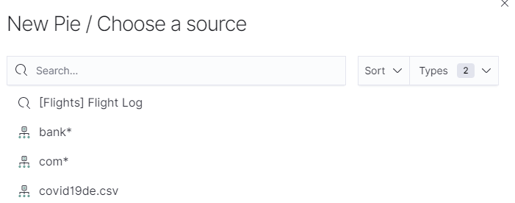

Step 11:Under buckets choose to split slices. Then under aggregation select range.

Step12: Under field select cumulative fully vaccinated

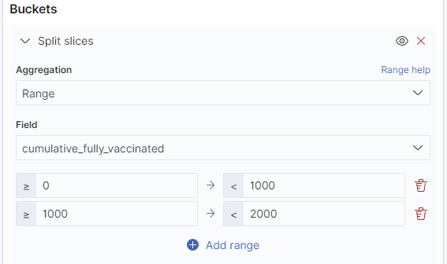

Step 13: Define the ranges to accurately show the data.

Step 14: Add another splice and under aggregation select terms

Step 15:The under field choose demographic value

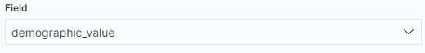

Step 16: make the timezone from may 1st to 8th year 2021

Step 17:Click update at the bottom right and then save

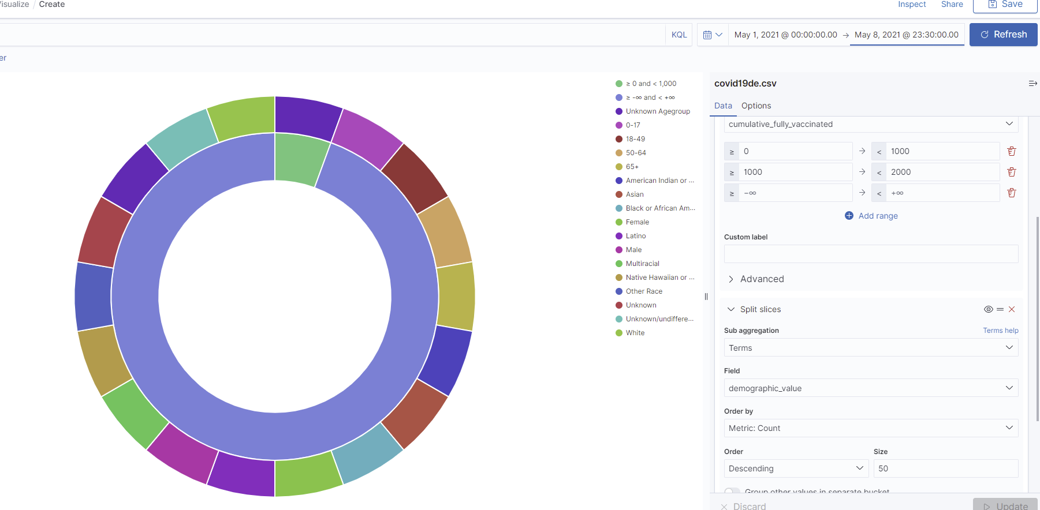

**Vertical Bar**

Step 1: Log into elasticsearch then maneuver to kibana

Step 2:Under the kibana tab on the left click on the visualizations

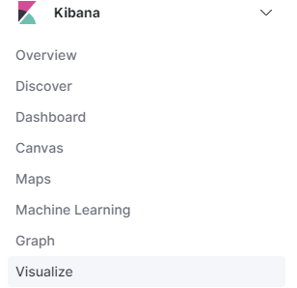

Step 3: Select create visualization at the top right and choose vertical graph

Step 4: Use the index pattern we chose to create the pie graph

Step 5: Under Y-axis make the aggregation be unique count

Step 6: Under field select administered date

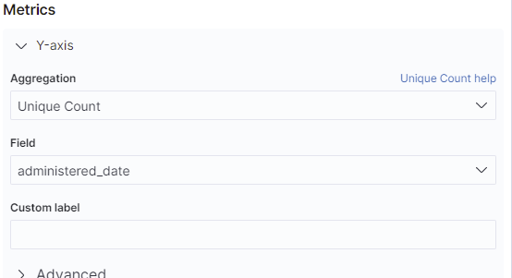

Step 7: Under buckets add an x-axis and under aggregation select terms

Step 8: Then under aggregation select terms

Step 9: Under field select cumulative fully vaccinated

Step 10:Change the date to 05-01-2021 00:00:00 ⇒ 05-08-2021 23:00:00

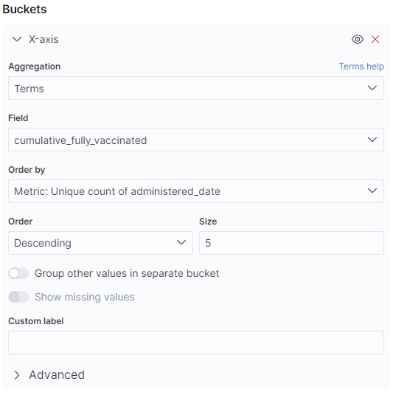

Step 11: Click update at the bottom right then refresh at the top



Step 12: Save and name the vertical graph

